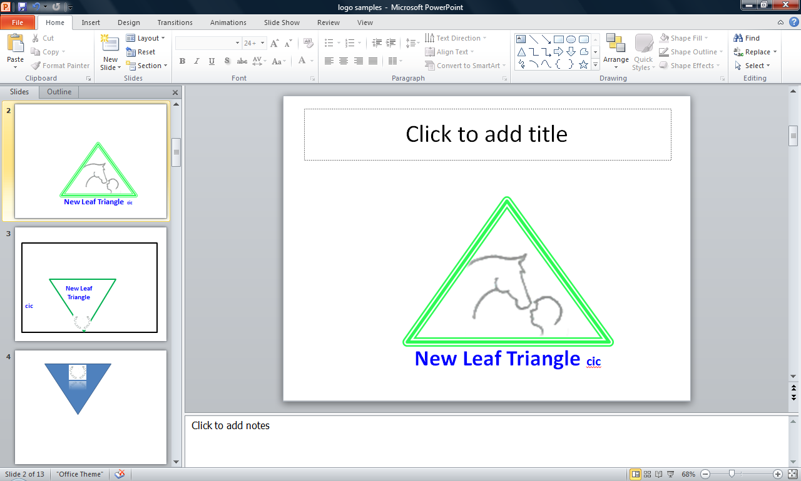 **New Leaf Triangle Dalby Risk Assessment**

**Address: Goadby Lane, Chadwell, Melton Mowbray, LE14 4LP**

**ASSESSOR/JOB TITLE: Directors**

**Name: Bryony Thurlow & Troy Shaw**

**Date 20.11.23**

**Review due: November 2025**

**KEY**

**RISK MATRIX**

**Risk = Probability (Frequency) x Consequence (Severity)**

**CONSEQUENCE (Severity)**

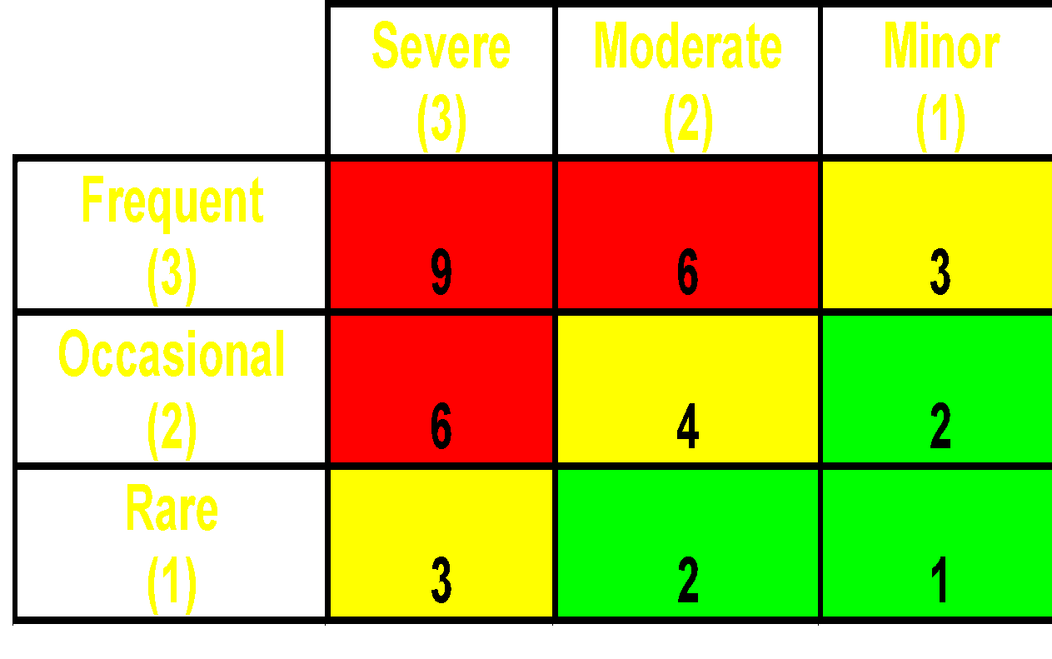

**P F**

**R R**

**O E**

**B Q**

**A U**

**B E**

**I N**

**L C**

**I Y**

**T**

**Y**

**ALL ASSESSMENTS WILL FOLLOW THIS MATRIX USING THE TRAFFIC LIGHT SYSTEM**

**Context**

New Leaf Triangle is an outdoor learning centre for individuals with a range of disabilities, autism and mental health conditions. The main activities at New Leaf Triangle take place at the 2 main sites situated on Goadby Road, Chadwell, Melton Mowbray, LE14 4LP (site 1) and Eastwell Road Site 2). The sites are 2 and a half acres and 5 and a half acres of undulating ridge and furrow grassland with a 20 X 40m sand, fibre and rubber menage at site one and 20 X 40m sand and rubber ménage at site two.

Site 3 is now under development at Old Dalby and consists of 50 acres of pasture land based on a large hill. It currently has stone outbuildings on the flat land. There is post and rail fencing of the perimeter and stock fencing as the land is also used for sheep grazing. Each section of field has an automatic water trough and hedge lines to separate sections.

| **NUMBER** | **HAZARD/POSSIBLE OUTCOME** | **GROUPS** | **RISK**  **RATING** | **CONTROLS** |
| --- | --- | --- | --- | --- |
| (HS) 1 | **Absconding** – students could abscond onto the road, over adjoining farmland or through dense woodland. They could get knocked over by vehicles, trip and fall, drown in any streams/ ponds, be injured by farm animals, come into contact with strangers or become lost. | Students | Yellow 3 | Students are to exit vehicles once inside the yard, when the gate is closed behind the vehicle, if they are likely to abscond. It is to be explained to students in a way that they understand that they must stay inside premises and not go onto the road or surrounding land and wood.  Students remain the responsibility of parents/carers and any external supporting staff while they are in the car park area and must be closely supervised at all times  Once in the yard the perimeter fencing is on the whole very good and hard to climb, however, it is not intended to be a secure facility and there are places that agile students could climb and abscond if they wished. Initial assessment must take into consideration this risk and all parties should discuss and agree whether the placement is suitable and the risks acceptable. New Leaf Triangle staff may however make the decision that it is not safe for an individual and decline the placement. |
| HS2 | **First Aid** – cuts/scratches | Students/  Staff | Green 2 | First aid kits to be present at all times. During transporting staff should make sure they carry an emergency first aid box and a fire extinguisher as per the transporting students RA. One member of staff on site from New Leaf Triangle needs to be first aid trained unless external accompanying staff are first aid trained.  At least one person from New Leaf Triangle must have a charged mobile phone at all times. Any staff going off site with or without students must have a charged mobile phone and sign in and out with a coordinator or director when moving from sites. |
| HS3 | **Animal Food -** ingestion | Students | Green 2 | The horses at Dalby have stored feed for the older horses when they need more energy or for medications. These are open and stored in the outbuilding area in plastic containers.  All students will be told that the food is for the animals and not for people. Staff will monitor to make sure the students are not ingesting any animal feed. If an amount of food is ingested seek guidance from the GP or NHS direct. |
| HS4 | **Tools** – misuse and trips | Students and Staff | Yellow 4 | Stable tools are kept in the shed or in the barn. The shed may be locked and other tools removed subject to the individual’s risk assessment. If in any doubt about the risk, metal forks, shovels and spades must be locked away.  Power and hand tools are not kept on site but may be transported if maintenance or improvements are needed to the site. Brushes, plastic shaving forks, poop scoops and wheelbarrows pose less risk and can be left out during most assessments but each case needs to be assessed individually. They are to be stored correctly in the barn or locked on the shed before students arrive.  A demonstration must be given by staff on how to use and store tools safely. Support will be given by staff when students are using the tools. They will only be using a metal fork, spade or shovel if they have steel toe boots or other suitable substantial footwear and receive training to do so. |
| HS5 | **Allergies** | Students/ Staff | Green 2 | The students may feed animals or come into light contact with either hay,straw, wood shavings or chopped rape seed. If they have hayfever or dust allergies they will be given a different task. If they still want to take part in these activities, they will be offered a dust mask to protect them.  Students with allergies to any of the animals or anything present in the environment may be advised not to attend and may be asked for a doctor’s note to say it is safe for them to attend. |
| HS6 | **Fencing and gates –** climbing over/falls/access to less safe animal areas | Students/ Staff | Yellow 3 | Initially only staff will open and close gates which lead to the paddocks. Students will be told this at the beginning of the session. They will also be told that they should not climb on fencing or other climbable items other than play equipment.  Staff must ensure they correctly close any gate after them.  Some students may be risk assessed to access the paddocks and open gates in order to fetch horses in as part of their programme. They still need to have the necessary assessed level of supervision for this task. Only specified staff & students should go in the fields with the horses at Dalby.  Students with severe autism and severe learning difficulties may find it difficult to understand this information, so will need close supervision. |
| HS7 | **Infection control -** Washing hands | Students/ Staff | Yellow 3 | There are some diseases that can occasionally be transferred from animals to humans, although the risk of this is very low. (See animal risk assessments) There are also likely to be germs in the environment. Hand sanitiser, wipes, hand soap and clean water are present at all times for students and staff to clean their hands.  Everyone should wash clean and sanitise their hands after handling and cleaning out the animals and before eating and drinking. |
| HS8 | **Animal handling** – behaviour around animals  (sheep and horses) | Students/ Staff | Red 6 | Staff are to read and sign individual animal risk assessments, especially the horse specific ones. The health and safety risks around animals are to be explained to the students in a way they understand, including the risks of bites, scratches, kicks and being trodden on and knocked over by larger animals such as the horses, goats or dogs. There will be a regular recap, where needed. All the horses at Dalby have access to most if not all of the fields and staff need to remember that the students will be around a loose herd of large horses that are not handled each day and come with subsequent risks. Students needs to have their hats on at all times and be mindful of reading the horses behaviour/body language and give them a large amount of space in case they move.  The induction advice to students needs to include how to act around each type of animal present at the time of their session. Students need to be assessed carefully and given the necessary support and supervision around the animals subject to the assessment.  For students with autism and/or severe learning difficulties, who may not be able to understand this information, close supervision is essential. Staff should monitor the students’ behaviour around the animals at all times and take the necessary precautions to keep students safe and protect the animals’ welfare.  If a student is injured, first aid is to be used where necessary. It may be necessary for the student to be taken to A&E or call 999 depending on the situation. This is to be decided by a senior New Leaf Triangle staff member, first aider or parent. |
| HS9 | **Trips/Slips/Falls** | Students/ Staff | Yellow 3 | Staff to warn students and other staff about the steepness of the hill and ground conditions as well as any other identifiable trip hazards around the site. The students are advised not to run around the Dalby site and this is to be monitored by staff. However it is an outdoor environment and hence surfaces may be uneven and objects such as sticks will be present so care needs to be taken by all individuals accessing the site.  *When taking photos people must be aware of their surroundings before taking the photo, i.e. to check there are no horses, other animals heading towards them. They should stand still to take photos and videos to avoid walking into objects, fencing etc.*  *When taking photos in other areas where horses are being ridden or used, permission should be sought from the supervising staff on site and people should remain in the area they are designated to avoid walking in front of horses or into objects.* |
| HS10 | **Water** – troughs,ditches and water bowsers could be a drowning hazard | Students/ Staff | Yellow 3 | There are a number of water troughs in each of the paddocks and sectioned fields  Although most of the water sources are shallow (roughly 0.4m - 0.6m deep, they could be a drowning risk to small children and if a student were to have a seizure near to the trough or bucket or to fall and knock their head. Students who are assessed as particularly vulnerable in this area should be supervised at all times when in the paddocks, near the pond or in the stables and animal enclosures. |
| HS11 | **Personal protective equipment (PPE) -** failing to use this could result in increased risk of injury in the case of an accident | Students/ Staff | Yellow 3 | Students are advised to wear hard flat soled shoes or boots which have heels for riding and being around the horses.  Students who are unable to do this due to sensory difficulties must be very closely supervised at all times when around the horses and should always ride with stirrups with toe guards or without stirrups to avoid their feet becoming trapped in the stirrup in the event of a fall.  Students should be strongly advised and persuaded to wear an appropriate standard hard hat when handling/ riding the horses.  All riding establishments require that riding hats worn at their venue meet current safety standards PAS 015 although the actual standard acceptable may vary, and their requirement for the riding hat to also carry the BSI kitemark may vary also.  New Leaf Triangle requires hats to be a minimum standard of PAS015 2011.  PPE for construction type activities is provided (gloves, goggles) and should be worn, as advised in construction & forest school Risk assessments. |
| HS12 | **Animal excrement -**  Ingestion could cause illnesses | Students | Green 2 | Some animal excrement can carry diseases, although incidences of this are rare. All students should be advised to wash their hands with hand sanitiser after handling and cleaning out the animals and before eating and drinking.  If a student ingests animal excrement, advice should be sought from NHS direct or GP. For students where this is a likely possibility, for example a student with Pica, they should be closely supervised at all times on the premises and could be advised that it is not a suitable placement for them. |
| HS13 | **Electric fencing –** could cause minor electric shocks and there could be risks from frightened animals who have been shocked | Students/ Staff | Green 2 | Electric fencing is to be turned off upon arrival to the yard by the staff. It will be turned on again once the students have left the premises. Currently it is only the pony paddock that has electric fencing. It needs to be turned off when feeding the ponies and poo picking to ensure their safety but needs to be on for the rest of the time to prevent them having full access to the grass paddock.  Although the voltage is no danger to human or animal safety, it can cause minor immediate discomfort and be alarming. However, the higher risk is from students handling animals who accidently touch the fence or if the shock travels through the students to the animal. In these cases the animal is likely to jump and flee and could harm the handler and others in close proximity, or, in the case of a horse being ridden, cause the rider to fall.  Where students are on vocational courses and there are no other students present, electric fences may be left on as part of the learning experience. |
| HS14 | **Safeguarding –** risks of abuse to children and vulnerable adults | Students | Yellow 3 | All New Leaf Triangle staff and volunteers will have an enhanced DBS check prior to working and there is a clear Safeguarding Policy. Staff undergo safeguarding training and are made aware of New Leaf Triangle Safeguarding policy and their responsibilities with regard to safeguarding during induction.  Trades persons or other external contractors/ persons will not be present during sessions unless they are dealing with emergency maintenance and situations that cannot be done at any other time, in which case they will be supervised by a staff member. Farriers, vets and animal experts may however be present as their work provides an educational experience but they will not be left alone with students at any time.  All staff and students need to sign in with a coordinator or director when they arrive/leave via text message until a diary is required. Aunty visitors need to have a visitors pass on them at all times while on site. If visiting both sites, they should sign in diary & visitors book at both sites. |
| HS15 | **Fire risks –** death/injury from flames and smoke inhalation  Also see fire risk assessment | Students and staff | Yellow 3 | * There is to be no smoking on the premises. All staff are to be told on their first day’s induction and staff are to make students and families aware of this rule. A sign is to be displayed clearly at the premises. * Hay and bedding is to be stored away from the main barn, in one of the two stables. Up to 3 plastic wrapped bedding bales may be stored in the barn at any one time but no hay or straw. * All exits are to be kept clear at all times. * Staff need to carry a small fire extinguisher in their vehicle in the event of an emergency. * The fire assembly point is in the hand standing access to the site. |
| HS16 | **Car park-death injury due to vehicles not dropping students safely and lack of hardstanding parking** | Students and staff | Yellow 3 | * The access to the site has a small hanging chain and a bike lock attached to the main metal gate which is coded. The entrance has some stone lay down and then when opened the gate gives space to some more hard standing that has room for 2 vehicles. Staff are to use this area to ensure their own and the students safety. |

| I have read and understand the New leaf Triangle Risk Assessment above and agree to follow its guidelines: | | |
| --- | --- | --- |
| Staff name | Signature | Date |
|  |  |  |